**1. Start up your web browser.**

2. **Start up the Wireshark packet sniffer, as described in the Introductory lab (but don’t yet begin packet capture). Enter “http” (just the letters, not the quotation marks) in the display-filter-specification window, so that only captured HTTP messages will be displayed later in the packet-listing window. (We’re only interested in the HTTP protocol here, and don’t want to see the clutter of all captured packets).**

Una vez arrancado Wireshark, comprobamos las entradas de conexión a nuestro ordenador

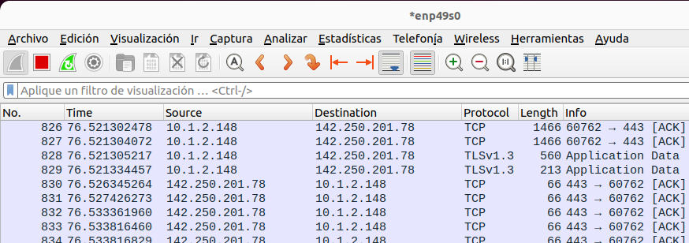

Si ya hemos realizado la accion, deberemos aplicar en el buscador un filtro con “http” y deberia de salir como en la siguiente imagen

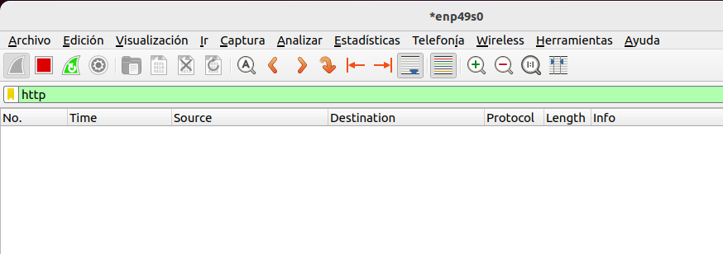

Lógicamente no veremos ninguna entrada ya que para buscar la conexión http deberemos hacer conexión con alguna web

**3. Enter the following to your browser**

**http://gaia.cs.umass.edu/wireshark-labs/HTTP-wireshark-file1.html**

**Your browser should display the very simple, one-line HTML file.**

A continuación, entraremos en el link que nos propone la actividad y deberemos ver el siguiente mensaje:

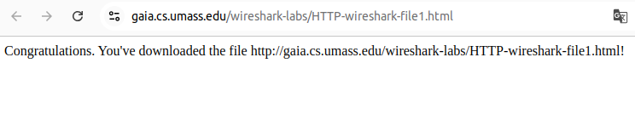

**4. Stop Wireshark packet capture.**

Si vemos el mensaje el siguiente paso sera parar nuestra captura

Una vez parada, para comprobar que lo tenemos bien, podemos aplicar de nuevo el filtro de “http” y en este caso si veremos las siguientes entradas

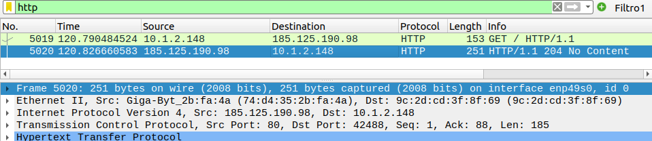

**1. Is your browser running HTTP version 1.0 or 1.1? What version of HTTP is the server running?**

Mi navegador usa la versión 1.1 como podemos ver en la siguiente imagen

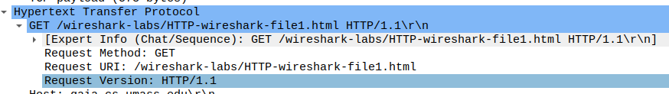

Y aqui podemos ver como la version del servidor tambien es 1.1

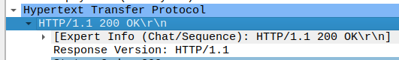

**2. What languages (if any) does your browser indicate that it can accept to the server?**

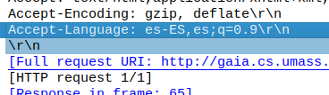

**3. What is the IP address of your computer? Of the gaia.cs.umass.edu server?**

Mi direccion IP es: 10.1.2.148 y la direccion de la pagina es 185.125.190.98

**4. What is the status code returned from the server to your browser?**

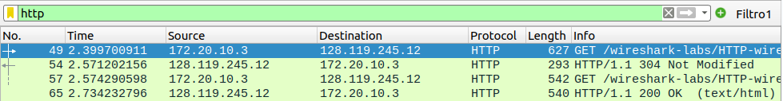

**5. When was the HTML file that you are retrieving last modified at the server?**



**6. How many bytes of content are being returned to your browser?**



**7. By inspecting the raw data in the packet content window, do you see any headers within the data that are not displayed in the packet-listing window? If so, name one.**



**8. Inspect the contents of the first HTTP GET request from your browser to the**

**server. Do you see an “IF-MODIFIED-SINCE” line in the HTTP GET?**

No, en la primera respuesta HTTP no encontramos ningun “if-modified-since”

**9. Inspect the contents of the server response. Did the server explicitly return the contents of the file? How can you tell?**

**10. Now inspect the contents of the second HTTP GET request from your browser to the server. Do you see an “IF-MODIFIED-SINCE:” line in the HTTP GET? If so, what information follows the “IF-MODIFIED-SINCE:” header?**

Si, en la segunda respuesta de HTTP encontramos la siguiente información:



**11. What is the HTTP status code and phrase returned from the server in response to this second HTTP GET? Did the server explicitly return the contents of the file?**

**Explain.**

En este caso tenemos el código 200 OK, esto significa que ha encontrado la página web correctamente



**12. How many HTTP GET request messages did your browser send? Which packet number in the trace contains the GET message for the Bill or Rights?**

Mi navegador envío 2 paquetes GET

**13. Which packet number in the trace contains the status code and phrase associated with the response to the HTTP GET request?**

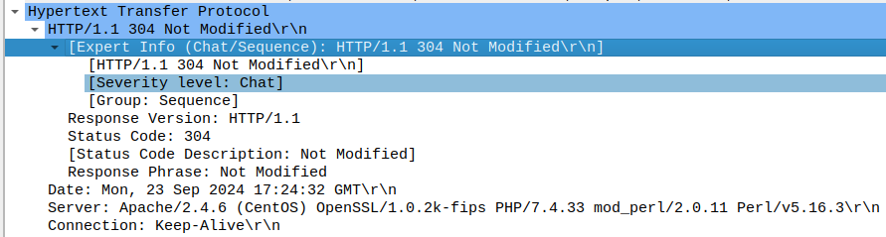

**14. What is the status code and phrase in the response?**

El código de estado más común que deberías encontrar es 200 OK

**15. How many data-containing TCP segments were needed to carry the single HTTP response and the text of the Bill of Rights?**

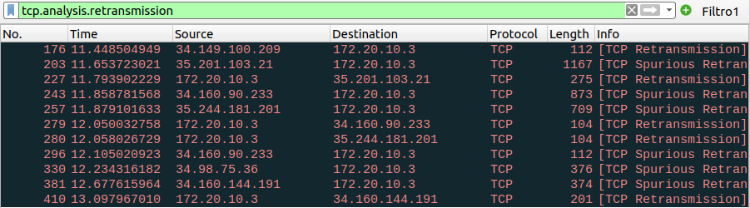

**16. How many HTTP GET request messages did your browser send? To which Internet addresses were these GET requests sent?**

Mando dos mensajes de respuesta

**17. Can you tell whether your browser downloaded the two images serially, or whether they were downloaded from the two websites in parallel? Explain.**